**BILAL SCHOOL- SECONDARY SECTION**

**MID OF TERM THREE EXAMINATION**

**GEOGRAPHY SENIOR ONE**

**TIME 2 HOURS**

**NAME…………………SIGNATURE……………….**

**Instructions to Candidates**

1. This Paper consist section A and B
2. All Section are compulsory.

**SECTION A**

1. Chemutai Faustine in his career of studying geography to become a pilot visited a meteorological center and found the following equipment installed at different positions. He then went back to his village and planned to mobilize the youth farmers to set up the same to overcome many climatic changes. The youth agreed to set up a weather station to overcome uncertainties of weather.

** Campbell**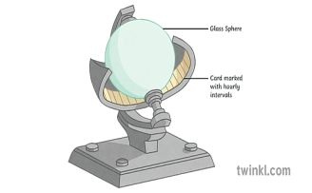

rain gauge

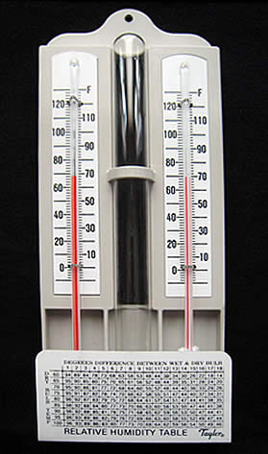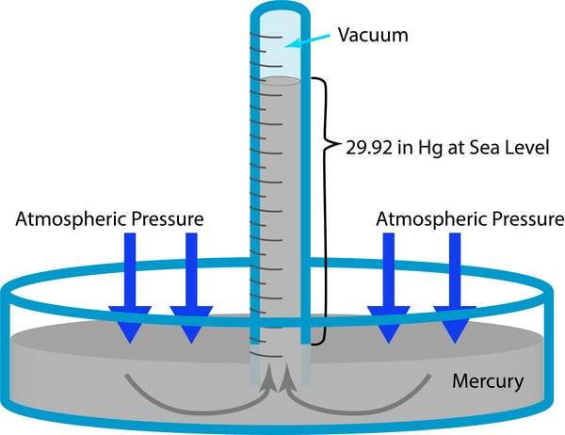barometer

hygrometer

how did they use the following instruments.

1. Rain gauge (04 marks)
2. Campbell sunshine recorder ( 04 marks)
3. Hygrometer ( 04 marks
4. A mercury barometer (04 marks)

(b) At Entebbe International Airport, the process of giving weather updates to pilots to prepare for the upcoming flight is called, ‘Briefing’. Said Faustine’s respondent. Mention four ways through which this process helps in aviation. (04 marks)

1. Tom left home for school very early in the morning when it was still dark. He reached school when the sun had risen.
2. Explain to Tom why this process happened (05 marks)
3. Explain to Tom about the other effects of the process. (10 marks)
4. What will happen to Tom’s shadow during different periods of the day? Give a reason for your idea. (10marks) 3 Kakiga wants to travel from Mukono to Iganga for his friend’s graduation party. He has a route map, but he is stranded about the transport costs he is to incur.
5. Explain to him how he can use a route map to determine the amount to be paid for transport given that each kilometer costs shillings 150 only. (07 marks)
6. Assuming Kakiga has now reached Hotel Continental in Iganga town because of your help. He is surprised that the area is so spacious. Please help him to find out the size of the venue using his map. (05 marks) C)How in four ways will Kakiga find the location of Iganga Taxi Park to be able to go back to Mukono? (08 marks)

**SECTION B**

**Answers should be written on the answer sheets provided. Neatness and clear presentation of ideas as well as use of relevant illustrations leads to more scores.**

1. On 15th April 2023, a group of researchers visited Kasenyi Landing site and they discovered that 66.6% of fish caught from Lake Victoria is from Tanzania, 18.6% from Lake Victoria Uganda and 14.8% from Lake Victoria Kenya.

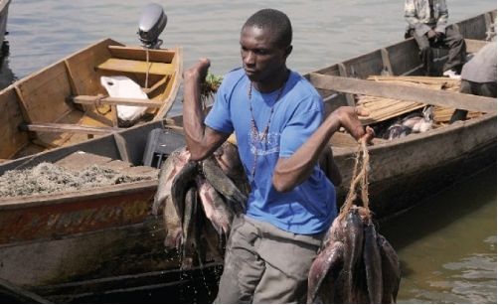

**Support material**

***Task:***

1. Explain how the researchers obtained this information. (04 scores)
2. Summarize the above information using an appropriate diagram. (06 scores)
3. The Ministry of Agriculture Animal Industry and Fisheries (MAAIF) has organized a conference to discuss about the significance of the fisheries sector of Uganda. Write a speech you would present as the Head prefect. (10 marks)

1. You have read an article in the geography magazine and found a headline, “The earth’s speed around the sun is expected to be faster in 2024.”
2. Write a letter to your geography teacher and comment about this headline. (10 marks)
3. Write a brief newspaper article commenting about how this movement influences human life on earth. (10 marks)
4. You have been chosen as a student of geography to talk about the environment of your school, during one of the school exhibitions. A) Explain how people in your local community affect, destruct or destroy the environment.

(b) As a senior one geography student explain how you can advise people in your local community to preserve the environment.

7.Your geography teacher asked you to carry out a field work of your choice and come up with the following.

(a) state the topic

(b)Outline the objectives of the study

(c)Explain the methods you used to collect data.

**The End……………Good Luck**